# **Mock Exam 2**

**Date:** 29 June 2023

**Name:** Haffiz

##### Q1

1. 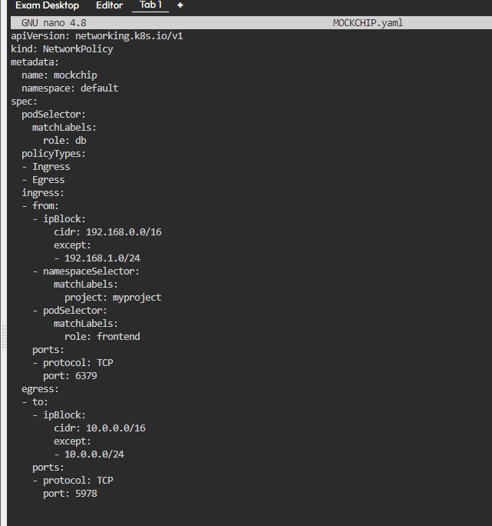
2. A screenshot of a computer program

   Description automatically generated

##### Q2

1. A screenshot of a computer screen

   Description automatically generated
2. A screenshot of a computer program

   Description automatically generated
3. A screenshot of a computer program

   Description automatically generated

##### Q3

1. A black screen with white text

   Description automatically generated

##### Q4

1. A screen shot of a computer

   Description automatically generated
2. A screen shot of a computer

   Description automatically generated
3. A screen shot of a computer

   Description automatically generated

##### Q5

1. A screenshot of a computer program

   Description automatically generated
2. A screen shot of a computer

   Description automatically generated
3. A screen shot of a computer program

   Description automatically generated
4. A screenshot of a computer

   Description automatically generated
5. A screen shot of a computer

   Description automatically generated
6. A screenshot of a computer

   Description automatically generated
7. 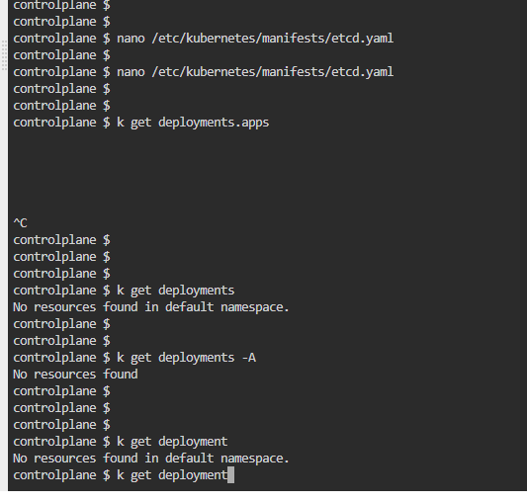

##### Q6

1. A screenshot of a computer

   Description automatically generated
2. A computer screen shot of a program

   Description automatically generated
3. A screenshot of a computer error

   Description automatically generated
4. A screen shot of a computer

   Description automatically generated

##### Q7

##### Q8

1. 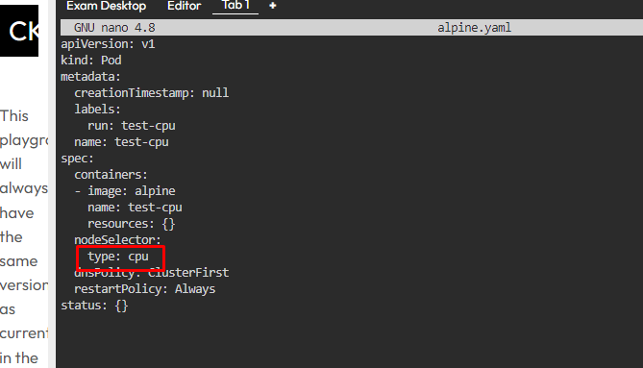
2. A screenshot of a computer program

   Description automatically generated
3. A computer screen shot of a black screen

   Description automatically generated
4. A screen shot of a computer

   Description automatically generated

##### Q9

1. 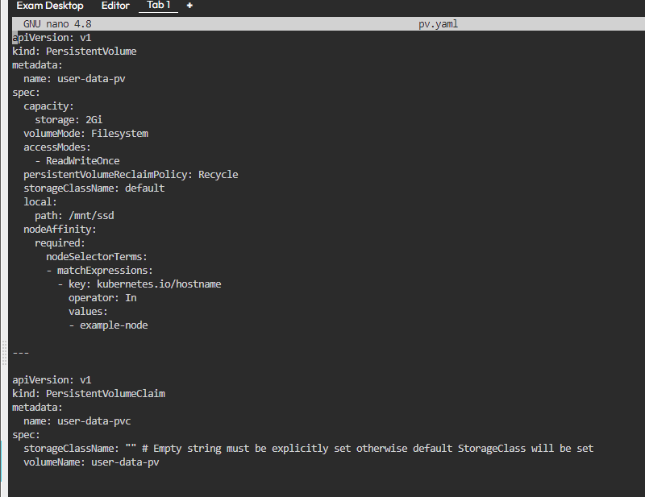
2. A black screen with white text

   Description automatically generated
3. 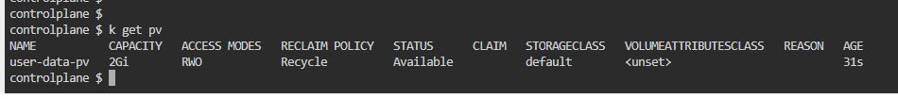
4. 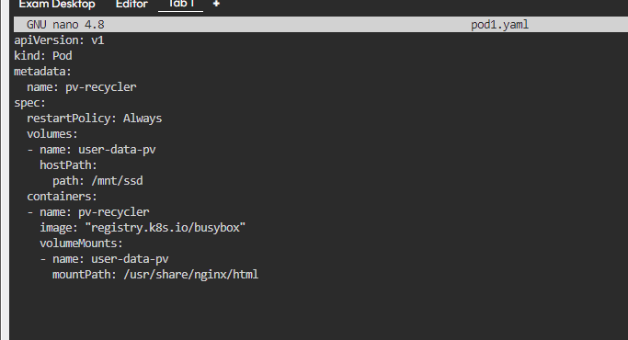
5. A screenshot of a computer program

   Description automatically generated
6. A screenshot of a computer program

   Description automatically generated

##### Q10

1. A computer screen shot of a program

   Description automatically generated

##### Q11

##### Q12

##### Q13

1. A screenshot of a computer

   Description automatically generated
2. A screenshot of a computer

   Description automatically generated

##### Q14

1. 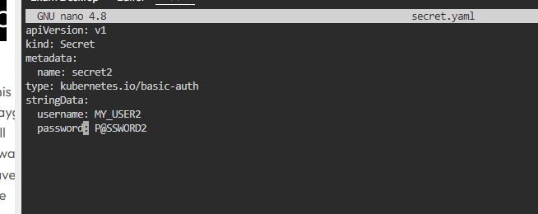
2. A screenshot of a computer

   Description automatically generated

##### Q15

1. 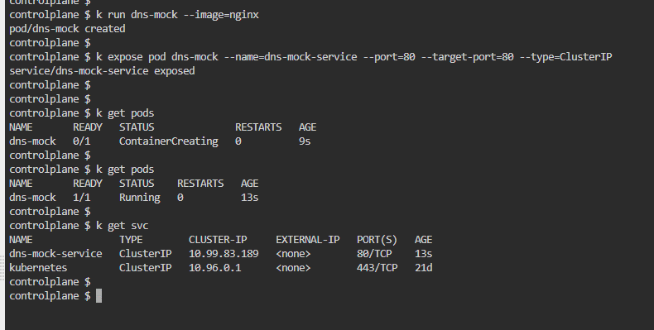
2. A computer screen shot of a black screen

   Description automatically generated

##### Q16

##### Q17

1. A screenshot of a computer

   Description automatically generated
2. A screenshot of a computer program

   Description automatically generated
3. A screenshot of a computer

   Description automatically generated
4. A screenshot of a computer screen

   Description automatically generated